Memorial Service
Celebrating the Life of
Alan Martin Donald
January 30, 2014
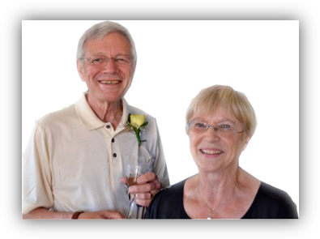

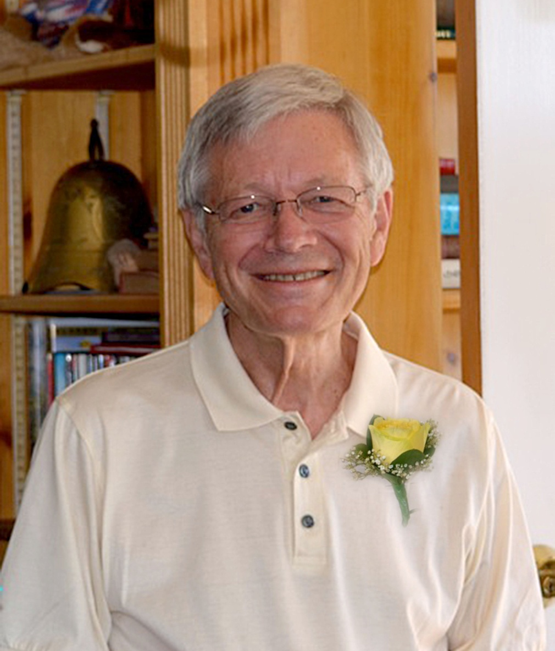
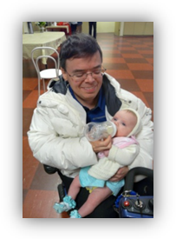

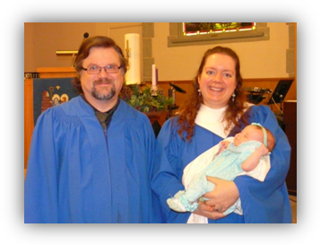
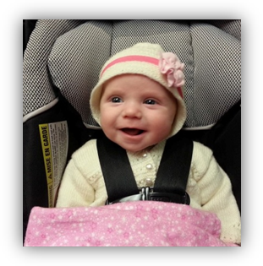

Please join us directly after the service downstairs in the Church auditorium for refreshments and more time for sharing memories. Two guest books will be available to sign (please include your email address) and some copies of Al’s music cd’s and dvd’s and short story (Family Homes of my Youth) will be available for you to take home.
Thank you all for giving your support, comfort, and friendship to the Donald family. You are a blessing to our lives and to the life of our very special husband, father, and friend.

Maureen, Chad, Randy & Skye,
and Charlotte-Star.

September 1941 – January 2014

Celebration of Life
North Lonsdale United Church

Officiating
Reverend Robin Jacobson

Welcome & Opening Words

Opening Prayer

Hymn: The Lord’s my Shepherd

Reading of Scripture (Randy Donald)

Solo (Skye Donald)

Eulogies
- Ted Stedman (including Bob Steele)
- Others?

Message

Time for Reflection: Just a Closer Walk with Thee

Committal & Prayer & Lord’s Prayer

Hymn: Guide me O Thy Great Jehovah

Blessing

Hymn: Go Now in Peace’

All welcome to Reception in Auditorium

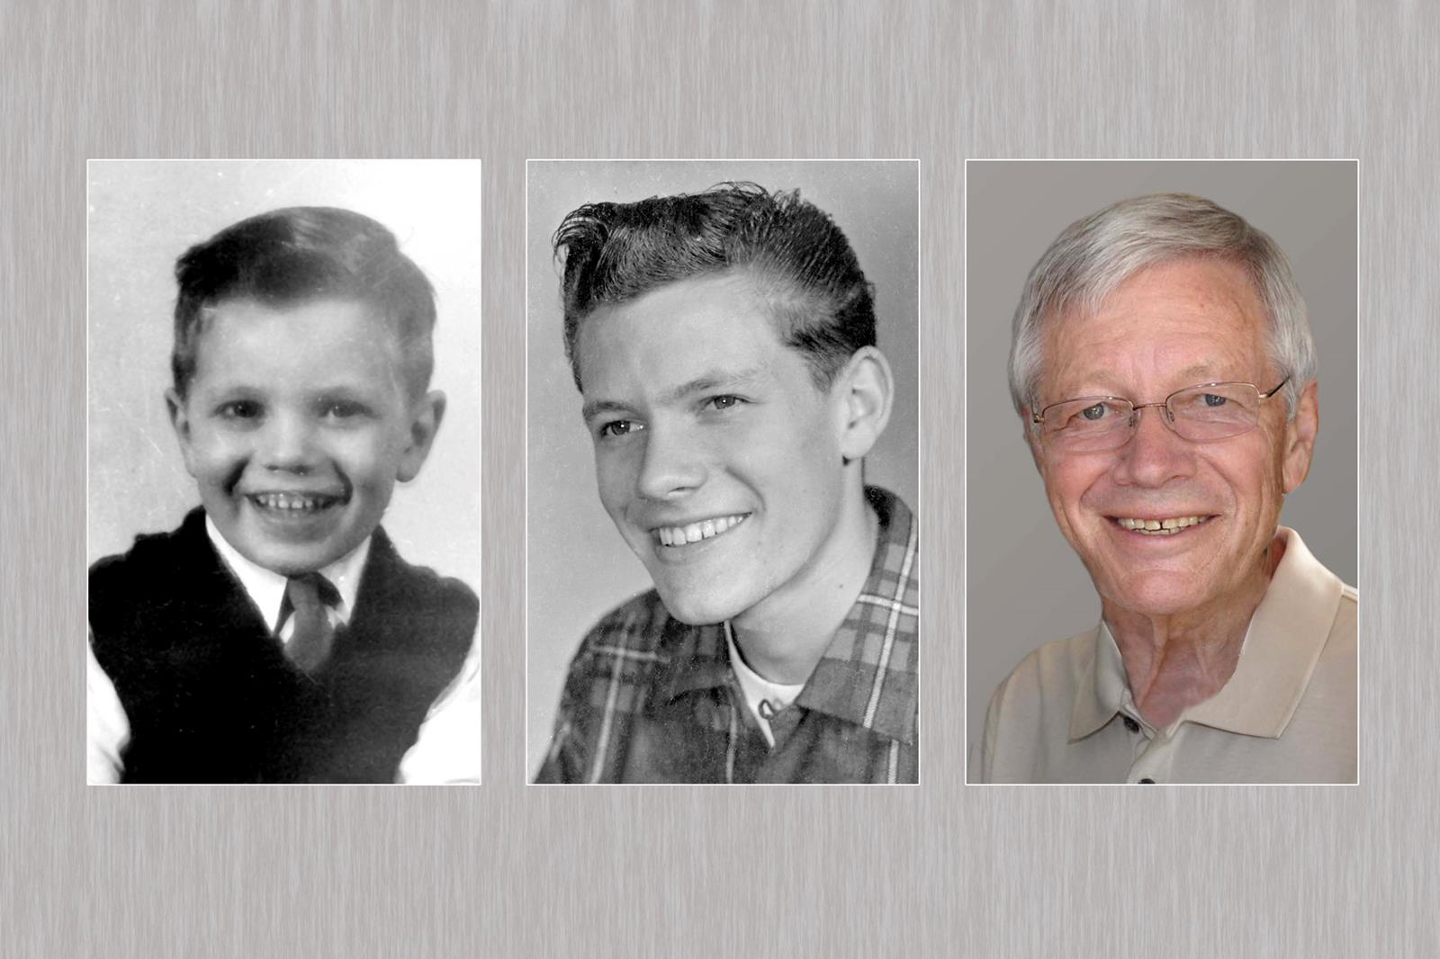

Friends

Friends are nothing till they sing
(laugh, pray, love) together,
They must sing the whole day,
They must sing the night away,
They must sing together,
they must sing.

Friends are nothing till they part
With teardrops in their eyes,
They go their separate ways,
Till they meet again someday.

